EXPERIMENT 1
Execute and display the results for the following commands in Kali Linux Operating Systems:
rm command
users command
tree command
AIM : To execute and study the rm, users, and tree commands in the Kali Linux operating system and observe their outputs.
DESCRIPTIONS
1. rm Command
The rm command is used to remove or delete files and directories in Linux. It permanently deletes files without moving them to the recycle bin.
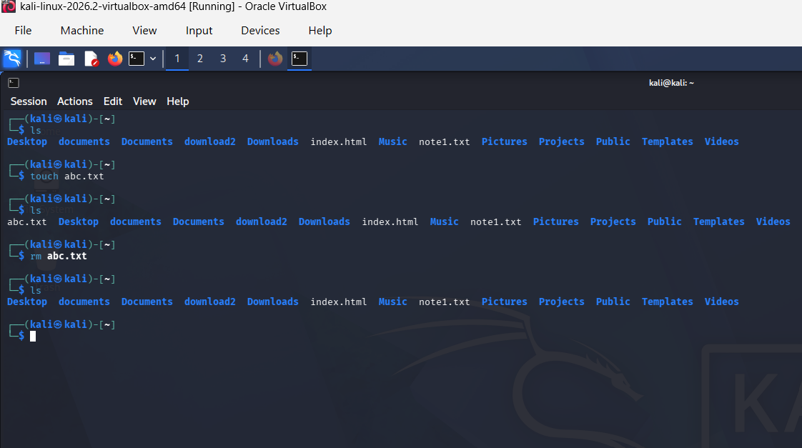
2. users Command
The users command is used to display the usernames of users currently logged in to the Linux system.

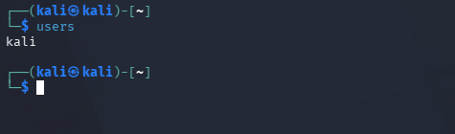
3. tree Command
The tree command is used to display files and directories in a hierarchical, tree-like structure. It helps users understand the organization of files and folders.
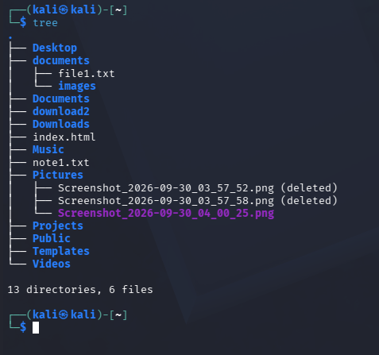
RESULT : The rm, users, and tree commands were successfully executed and their outputs were observed in the Kali Linux operating system.

